**Re-read the `dcdiag /v` output line by line.**
During the diagnosis it was found that some of the tests did not pass:
Fail 1: DFS Replication (DFSR)
AD DS installation: probably functional
DFSR/SYSVOL health: currently unhealthy
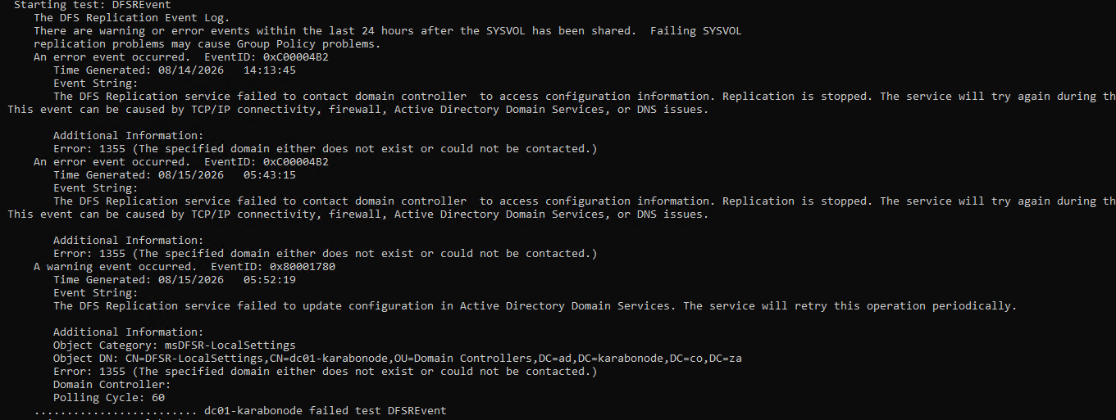
Error: 1355 - The specified domain either does not exist or could not be contacted.
Problem Defined:
The DC is trying to communicate with AD and is failing to locate/contact the required Domain Controller
After you promote a DC on an Azure VM, the VM's network adapter is often still pointing at Azure's default DNS instead of at the DC itself. So the DC's own DNS server role is running, but the machine isn't asking it for lookups — it's asking Azure DNS, which knows nothing about ad.karabonode.co.za. Result: "domain could not be contacted."
Closing: The diagnosis of the drcs usually shows erros of the passed 24hrs, so that error might have been an error that occurred hours ago.
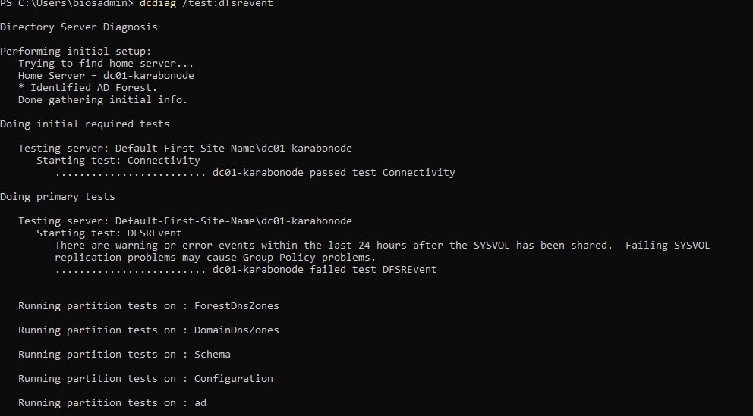
The command scdiag /test:dfsrevent was ran and It returned a passed connectivity test but also showing the error we encountered.
Week 1 Summary
What Was Built
- The first thing I built was the resource group rg-karabonode. This resource group will be used in our project to keep resources such as the virtual machine and virtual networks that we are going to use for this project.
- I also added a Virtual Network (VNet). This Virtual Network was going to be used for the virtual machine.
- I had to learn a few terminologies for AD DS because we were about to build our own server, and it required us to have some knowledge of the type of Active Directory environment we were working with.
- There were five FSMO roles that we had to understand: Schema Master, Domain Naming Master, RID Master, PDC Emulator, and Infrastructure Master.
- During Day 2, we had to create a virtual machine using Windows Server 2022 Datacenter: Azure Edition, with 2 CPU cores and 4 GB of RAM. Of course, it was expensive, but as long as I deallocate the VM when it is not in use, the costs should not be too heavy, as I will mainly be charged for the disk. We also had to configure the NSG to ensure that only our IP address could initiate an RDP connection to the server. I managed to log in to the VM successfully.
- During the setup of the VM, we learned that SYSVOL and NTDS.dit needed to be stored on separate disk storage. It was not a good idea to share the same storage with the operating system because it could affect the I/O performance of the data. I therefore decided to get an additional 32 GB SSD to prepare it for the SYSVOL and AD database.
- On Day 3, we configured the file partition of the extra disk storage we obtained and assigned it the F: drive letter. We then installed the AD DS role. Before configuring our forest, we first needed to make sure that we understood the parameters before installing it. This allowed us to understand what PowerShell commands we were typing instead of simply making it a copy-and-paste activity.
- On Day 4, we finally set up the forest, provided the correct parameters, and configured the DSRM password, which was different from the password we use to log in to the server. I then used dcdiag /v to check the health of the forest. At first, there were some errors, especially related to the DFSR events. However, it was clear that some of these errors had occurred hours earlier, as the diagnosis showed errors that had occurred within the previous 24-hour interval.
Why Does This Matter?
- This matters because it helps you understand the overall structure of AD DS and how the different components fit together when setting up a new Active Directory environment.
- It also helps you understand how to troubleshoot errors that may occur in AD DS. You will be able to check logs, identify errors, and diagnose the AD DS environment when issues occur, such as domains not working correctly or replication problems.
- Another important point is understanding how storage is separated. For example, keeping the AD database and SYSVOL separate from the operating system disk can help prevent issues with the OS disk from directly affecting the AD database and SYSVOL.
Skills Covered
- AD DS health-check interpretation
- Technical troubleshooting and error diagnosis
- Technical write-up and documentation
- FSMO role recall and understanding
- Active Directory Domain Services deployment
- Windows Server administration
- Azure Virtual Machine deployment
- NSG configuration and RDP security
- PowerShell parameter understanding

